**Requirements**

**Set Up Considerations**

Deliverable (A document need to be developed)

A documents needs to be established for the setup requirements for seismic zone.

* Roles
  + Katalyst Client (storage client)
    - Set up as a Katalyst user and when they enter seismic zone information
    - QI’s will be tracked in the Client Sale and Trade on industry brokerage lines
  + Contributing Company ( but not a Katalyst company)
    - Set up as a Katalyst user and when they enter seismic zone information
    - QI’s will be tracked in the Client Sale and Trade on
    - Load lines into their own database
    - Assign Eye glass user account
    - Sale and Trade activity tracked
    - Same ability to manage line list and approvals as regular company
  + Broker
    - Set up with roles that reflect he is a broker
    - Tracking of his QI on the system.
    - QI material is delivered to him.
    - Client Partner approvals delivered to him
    - Broker Billing etc. is all in the system
    - He needs to have the ability to enter files information into Seis Zone.
  + Marketer/Admin (Katalyst Employee)
    - Super User Privileges
    - Can see restricted layers, etc.,
    - System overall activity performance
    - Can login as a super user
    - May have better QI material, unstriped sections.
  + User (Registered User)
    - No associated to a Katalyst Company
    - Has established a user Login
    - QI tracked with user
  + Contributing Client Requirements
  + Data Manager
    - Email, Contact, Location, etc.
  + Accounting Contact
    - Email, Contact, Location, etc.

**Business Process**

Diagrams Role

The business process need to be mapped out in detail. It needs to be defined specifically for the roles that are presented. A documented process will allow you to refine the software and the system requirements. A process document for exist for each of the following roles so that if the process changes, you will change the document and it is on record the impact of the change.

(Guest, Client, Broker, Marketer/Admin).

Business rules need to be put into place to insure that the process need to adhered to.

Fee’s

The cost for the services need to be aligned with industry and incorporate industry terminology. Seismic Zone can facilitate/adhere to current industry standards and provide a viable alternative, since they can provide a better level of service.

1. How do I track DM fees?
2. How do I track Broker Fees?
3. How do I track specially negotiated contract fees?
4. The tracking of fees needs flexibility and be supported by a document of how they will be applied.

**Example**

One example of partnerships that need to be established with the Katalyst clients is that all data sales for their database are initiated through Seis zone and managed by Seismic Zone data managers. Katalyst needs dedicated partners with data and exclusivity to sell their data to develop Seismic Zone as a market place.

**Marketing Agreements**

This agreement type would work at the line level where you are given permission to sell data that is 100% owned. Scanned marketing agreements needs to be associated at the partner/line ownership level. (All Rights, Conditional Rights, No Rights)

Marketing agreements may have a term of 3 years or something like that, so the term needs to be defined.

Changes may take place over a period of time, the agreements need to respect and represent those changes.

**Login to Seismic Zone**

The login to Seis Zone needs to establish the role of the user in Seis Zone associate to a company. The current separate login for Seis Zone should not be required by Eyeglass users.

Login need to establish his role in the use of Seis Zone.

* Security - Based on that role and Companies, Groups, Users, Applications, Preferences he many be associated with. The security should be database driven and the reports should be defined in the security in terms of what each user gets to see.
* Oil Companies will almost never purchase the data from the website with no broker or Katalyst representative being involved in the purchase. All people logging in need to have a company that is associated to the login in the Katalyst BA. A strategy needs to be established for each company with respect to storing their entitlements.
* Every contributor to Seis Zone should have it lines loaded into an Katalyst account they manage. Once loaded into this instance, then eyeglass needs to have its features extended so that clients can add or remove lines form the Seis Zone.
* Seismic Lines
  + Line layers that they own or have an interest in.
  + Entitlements (Trade Data Purchases)
* Seismic Land
  + Their own land Layer
  + Open Crown, Disposed Crown, Freehold Land
* Seismic Wells
  + Wells (Abandoned, Standing, Drilling Licenses, Producing, etc.)
* Reports
  + The reports that they are eligible to seen in Seismic Zone for the users.
* Data Availability (Status)
  + Data sets that are readily available data need to be identified on the maps so that brokers or anyone surfing on the site know that they can order and receive the data in a matter of hours. It should represent clearly that Katalyst is managing and hosting the data.

**Map Presentation**

**The Map needs to be customized to the user login, roles, contributing data, wells, and their company’s**

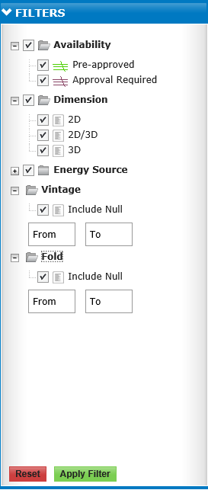

These layers on the map need to be database defined and driven. The Map needs to be as simple to use as possible.

* **Pre-approved** – this should mean that Katalyst has all the approvals in place and can take the sale to completion. It means that you have within your organizations access to the QI material and can get access to the physical data in the case of a sale.
* **Approval Required –** This means there are conditions that are associate with the sale of the data, the conditions could be Partnership Approval, Client Approval, Data Completeness, etc.
* **Dimension –** Remove the 2d/3d flag it is confusing and not necessary.
* **Energy Source** (REMOVE) – This should be removed from the map legend, it does not make sense to have it here and filter it here, the list is too long, and searching for data based on source does not happen. Essentially source is usually considered once the with area of interest has been established.
* **Vintage** (REMOVE) **–** remove from the legend, is does not make sense there.Vintage will be of interest once it is established that the data is in the area of interest.
* **Fold** – Fold is not longer a good parameter for the legend and should be removed. Fold can be increased with certain processing techniques; fold should be removed from the legend.
* **Price** – I would include price on the MY AOI for consistency. Price should not include a price for partial data sets. Price is really the starting price, you should have approval from you clients to give discounts up to 25% without having to get approval.

**Add Map**

* Database Managed – Layer Control, layer can be added or removed from the map based on entries in the database.
  + Layer Control – Land Layers, Heritage, etc., Open and Disposed
  + Layer Control – Well, well logs, etc.
  + Layer Control – Client Entitlements, Sales History
  + Layer Control – Land Sales, Block Sales, etc.
* Legend on Map (Top right corner)
  + A drop down legend should be added to the map for Basin, and general map culture driven layers. Basins, Grids, Blocks, Culture, Permits, etc.
* Base map
  + The base map, Street, Terrain, Satellite, etc.
* Search Engine Incorporations
  + City’s, towns, lakes, etc., google map overlay maybe.
  + Street view, incorporating bigger data.

**Reset / Apply Filter**



* Remove – this button should be removed because the legend should be interactive with the map. This does not conform to any map standards development that I have seen before.

**Region Setting**



* Expand - This region setting should redirect the site to look at the different database located to different regions in the world. It should interact with and impact data layers, units and measures, it should also impact who get communication with regards to a QI, and may even impact where the data is severed from. The contact information etc. on the map should also be associated to region. It should be a user preference setting and it should dictate where the map is centered.

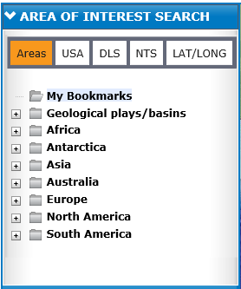

* Geological Plays/Basins – I would simple remove from map it is confusing here and simply let people turn on the layers that outline them in the legend.
* All those continents, I am not sure if it adds any value to the map. I would likely just remove them as I don’t really think they will ever get used.
* The bookmarks work well.
* The other search on the top are good.
* This entire area on the map page is a little confusing, complicated.
* If you could do a google map overlay and have that search available that would be useful and greatly enhance the data available and the search ability of the site.

**MY FOCUS**

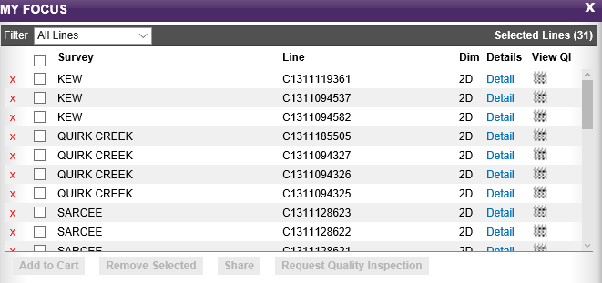

* **Changes to My Focus**
  + The QI data should be put on disk, this would improve the retrieval and rendering making the process more responsive and more reliable for the end user. Additionally, if the QI data is directly available to the package builder application the ability to programmatically create QI packages would be a lot easier.
  + I would leave the Survey Name off this page as it takes up too much room in its current form and is not important here. I would simply maintain the Line id.
  + Fold should be added as a column and it should be able to sort the lines based on fold.
  + Source should be a field in this display and should be sortable.
  + Vintage should be a field in this display and should be sortable as well.
  + Rem**ove Selected**, this should be changed to **REMOVE LINES,** the lines are not selected are removed from the My Focus dialogue.
  + Request Quality Inspection – this entire process needs to be changes and become **broker friendly**, the person who requests the quality inspection will be permitted to enter his own internal **Reference number**. That will be able to enter some **Notes** with respect to the Quality inspection. It also be associated with the status of the QI. The person who requests the QI will not necessarily be the person who will ultimately purchase the data.
* **Sale of Seismic (Discussion)** 
  + The web site will facilitate online QI of data it is unlikely that data sales will take place on line. At least not initially until the process is more refined and well established.
  + This site really needs to manage the QI process with eloquence and in a way that client can see they are being responded to, get feedback on where their request is in the QI process, manages the client expectations.
* Relationship with My Focus, Cart, History – This needs review and refinement.
  + **My Focus** – this should be the buffer that you manage the cart with, it is really a working space and it is for a specific area accurately describe as My AOI. The buffer allows the user to add lines to a cart that are associated with your working session. It should take the exact same form as the Order Cart and establish consistency and continuity in the application.
    - **Map Highlight** all the lines in My Focus should highlight on the map. This is before a QI request is made providing the client has a clear picture of the lines and area the he is requesting when he loads them to the cart from the My AOI dialog.
  + **Order Cart** – the order cart contains the line that are submitted for QI and should be considered as all the lines/survey associated with a single request. The order cart should only contain the lines for that current login working session. Historical lines that are left over could be there but a line count should be on icon or something like that so that clients know that they have additional lines in the order cart. All QI request should be processed through the order cart as a consistent process. This means a QI request from my focus should check the order cart if there are additional lines and present the order all at once.
  + **Order Cart**-the creation of an entry in the order cart should also make an Entry in the Sale and Trade module in the melting pot. I believe it does but the Sale and Trade module needs to be significantly enhanced, to reflect an order that could have multiple transactions, with a spatial polygon stored for each 3d survey. The sale and trade module in the form it is currently does not support the concept of entitlements. Lines added to Sale and Trade need to be associated initially with a transaction type of QI.
  + **Prices** should only be the prices per line and not prices for partial, it doubles the amount of work, no one ever pays list price, so it is a not necessary, the prices should be the current price. All totals should be left off because all your lines don’t have prices and it just adds confusion to the entire process. Completeness of data and maintenance of data with respect to the site is important for the success of the site.
  + **History** should be a place that you go to, to review the progress of your QI request. The history front page should provide the following status.
    - Summary Screen
      * My reference number
      * My comments
      * Data QI submitted
      * Number of lines with QI material
      * Number of lines Pending QI
      * Reason they are pending for the QI, Partnership approval, Inventory request, et
      * Last updated
      * Status (Complete, Ongoing, Canceled, Sale), etc
    - Detail Screen
      * Will project the status information regarding the order cart
      * Adds status and attachments that are associated with the order
      * Approvals, etc.
      * History of communication with the client
      * Status of all lines in the QI request in terms of QI process
      * If the line does go to sale a copy of the invoice should be attach.
      * If the line does go to sale a copy of the Transmittal should also be attached.
    - The information in the history section will be interactive and be updated over and over again until all the information has been collected and the order completed, the history record should be drive from the status of the entry in the Sale and Trade module in the melting pot. Sales and trade will need to be extended to support this functionality.
    - A blog with the sales desk should be present in the History so inquires can be made and the responses recorded. The sales desk also needs to have some ability to negotiate with the company.
* **Middle Ware**
  + Middleware need to be incorporated into the infrastructure of the system. Many of the features needed in Seismic Zone, could be generated within FME.
  + The middleware would introduce the ability to powerful web services to every application with a very limited amount of development.
  + The Middleware infrastructure can be used for many applications throughout the organization, it would be in integral part of the system and facilitate automation. The implementation of a server would provide automation, scheduling, prioritizing, in a well managed environment that can be replicated with simply scripting.
* **QI Requests Clients 2D (FME Generated)**
  + Qi request should in a plat with all the lines.
  + A parameter sheet with all the parameters including pricing
  + All the sections that are associated with the QI materials.
  + If the QI is requested by someone who is a broker, the Partner requests for are QI are supplied with the QI material that need to be returned.
  + A link should be provided to the client with the ability to down load the QI request to this system, and access to this line needs to be tracked.
* **Qi Requests Clients 3d (FME Generated)**
  + An automated generated plat of the survey outline
  + A parameter sheet of the survey parameters
  + The 3D will be staged on a work station for the client to review
  + If a broker, make the request partnership approval will be supplied
* **Sale and Trade Review**
  + It and trade need to be able to handle the entire QI Process
  + It needs to facilitate the generation of QI packages and deliver them.
  + It needs to track this entire process interactively for QI packages.
  + It needs to track and manage partnership approvals.
  + It needs to be able to break down one QI request into a number of transactions
  + It needs to store the list price and the sale price
  + It needs to store the fee’s (data management, brokerage, third party, etc)
  + It needs to create credit notes and invoices based on BA. One BA needs to exist that supports the entire sales process.
  + It needs to capture a copy of the price and partnership breakdowns at the time of the sale.
  + It needs to be more generic so that it can process multiple transaction types.
    - Review, Purchase, License, Land, wells, etc.
  + It needs to be able to support spatial polygons for the entitlements of 3D, the current entitlement model is incorrect.
  + It needs to capture the no permits present on the survey at the time of sale.
  + It needs to store scanned documents.
  + It needs to store transmittals and work order or have an association of them.
  + It also need to store conditions associated with the sales.
  + A link of the inventory items should be associated with the sale as well.
* **Additional Features**
  + Features should be added to include shape files, segp1, etc. for downloads this can be accomplished by using fme with little effort and a web service.
* **Architecture Considerations**
  + Integration with Eye Glass so lines can be added and removed from the Seismic Zone by the Eye glass user with relative ease.
  + BA usage review, companies that post data into Eyeglass need to have roles setup up that support the business processes of the website.
  + I am concerned about how BA’s will flow through the system and how they will impact the melting pot and local seis zone user accounts.